BOWLING FOR RHINOS
Friday, June 23rd, 2017
5:00pm-9:00pm
Olympus Hills Bowling Alley
4015 S. Wasatch Blvd., SLC

It’s time to “Strike Up A Conservation!”
The registration fee is only $25.00 per person and you will receive:
2 games of bowling
Shoe Rental
All you can eat pizza and snacks
All you can drink soda
(Children under 10 years of age are only $10.00)

Make an additional donation and enter to win amazing prizes!
(Giveaways will begin at 6:00pm)
Donate:
$25.00 Registration.
+$50.00 Receive an event t-shirt and entry into our $50 door prize category.
+$100.00 Receive an event t-shirt and entry into our $50 AND $100 door prize categories.
+$250.00 Receive an event t-shirt and entry into our $50, $100 AND $250 door prize categories.
__________________________________________________________________________________________
REGISTRATION FORM
Name: ________________________________________

Address: ____________________________________ Phone: ________________

Email: ______________________________________

Please sign me up for the following:

Adult Registration Only $25 ______

Child Registration Only $10_______

Registration & Donation of $50-$249 _____

Registration & Donation of $250+_____

How many adult bowlers? _____ How many child bowlers? (10 yrs & under)_____

Make Checks Payable to Utah Chapter AAZK
Please mail to:
Utah Chapter AAZK
ATTN: Bowling for Rhinos
2600 E. Sunnyside Ave Salt Lake City, UT. 84108

For more information email: utahaazk@gmail.com
____________________________________________________________________________________________________________

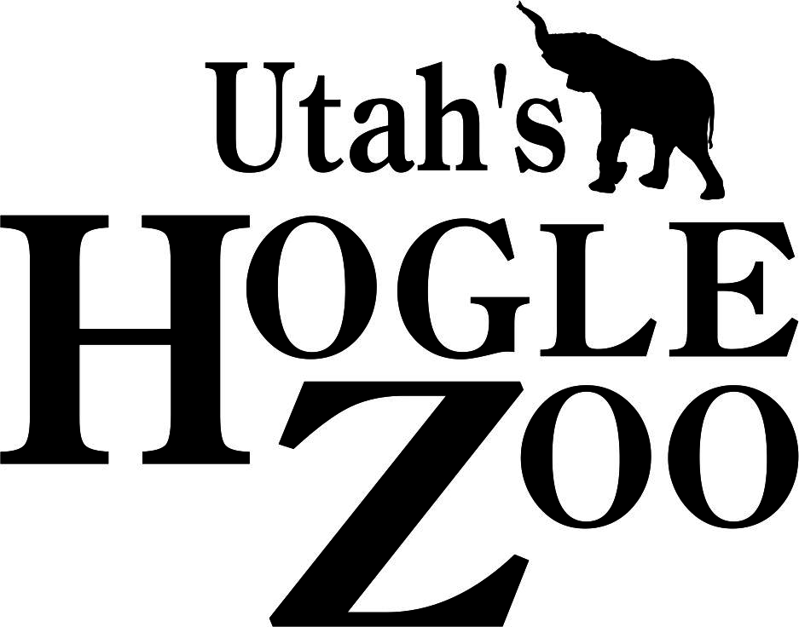
For use by AAZK Bowling for Rhinos Volunteers Only

Amount Owed________ Amount Paid________

